He Pīkau Mātauranga
A Knowledge Backpack

for outdoor leaders, instructors and guides
wanting to gain recognition of current competency

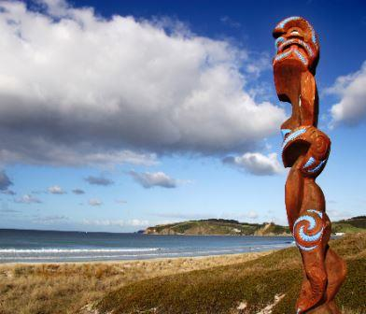

Contents

Welcome…………………………………………………………………………………….……………………………………………………………………………………. 3
RCC Pathway .............………………………………………………..………………………………………………………………………………………………….... 4
The NZ Outdoor Scene…………………………..…………………………………………………………………………………………………………………….…… 6
- History & Culture…………………………………………………………………………………………………………………………………………………….... 7
- Flora & Fauna……………………………………………………………………………………………………………………………………………………………… 9
- Weather…………………………………………………………………………………………………………………………………………..…………………………. 10
- Geology & Geomorphology…………………………………………………………………………………………………………………………………….…… 11
- Environmental Care…………………………………………………………………………………………………………………………………………………….. 12
- Land Access…………………………………………………………………………………………………………………………………………………………………. 13
- Health & Safety Legislation…………………………………………………………………………………………………………………………………………… 14
- Safety Management…………………………………………………………………………………………………………………………………………………….. 15
- Emergencies…………………………………………………………………………………………………………………………………………………………………. 20
- Outdoor Organisations…………………………………………………………………………………………………………………………………………………. 21
NZOIA………………………………………………………………………………………………………………………..………………………………………………………… 22
Assignment ………………….…………………………………………………………………………………………………………………………………………………….. 23

Copyright © NZOIA 2010
First published August 2010
Revised July 2015, 2018
No part of He Pīkau Mātauranga may be reproduced in part or whole without the written permission of NZOIA.
All efforts have been made to ensure the accuracy of information presented in He Pīkau Mātauranga but NZOIA accepts no liability or responsibility in this regard.
Cover photograph: Jakich, 'Māori carving, Omaha' from www.dreamstime.com.

Recognition of Current Competency Information
- for holders of overseas qualifications

Welcome
What is the most important thing in the world?
I will say
'tis people, 'tis people, 'tis people.
Behold the sneeze of life.

Welcome, welcome
Friend, greetings
Welcome to New Zealand
Welcome to NZOIA
Be stout hearted, be strong
I wish you all the best
Greetings.

He aha te mea nui o te ao?
Māku e kī ake
He tangata, he tangata, he tangata.
Tihei mauri ora.

Nau mai, hāere mai.
E te hoa, tēnā koe
Hāere mai ki Aotearoa
Hāere mai ki NZOIA
Kia manāwanui, kia kaha
Ka nui ngā mihi mōu
Tēnā koe.

Welcome to outdoor recreation leading, instructing and guiding in Aotearoa-New Zealand.
NZOIA qualifications represent the benchmark standard for people working as leaders, instructors and guides in New Zealand. Therefore, transferring your qualification to a NZOIA one makes professional sense and ensures your competence is well regarded and credible in the New Zealand outdoor community.
Before you embark on the NZOIA Recognition of Current Competency (RCC) journey, you must ensure:
- You are a current financial member of the professional association you hold a qualification with
- Your qualification is on the RCC Matrix
- You have a current First Aid Certificate
- You have a log book including relevant personal and instructional experience over the last three years

If the above criteria have been met, you are on your way towards the goal of full registration with the New Zealand Outdoor Instructors’ Association.
If you have lived in New Zealand for less than three years, you will need to complete a workbook, He Pīkau Mātauranga. In English this means ‘A Knowledge Backpack’ and inside this backpack are a number of topics that will help you to understand, and be part of, the New Zealand outdoor leadership scene.
Once again, welcome, and we trust that this recognition of current competency process will assist you in achieving a positive New Zealand experience.

RCC Pathway
Is your Qualification on the NZOIA RCC Matrix?
NO: Please inform NZOIA of your qualification and association. If we receive similar requests over a period of time we will investigate putting resources into getting them on the Matrix

Yes
No

Have you lived in New Zealand for more than three years?

No

Yes
Submit your RCC Application
Request a ‘He Pikau Matauranga’ Workbook

Submit your RCC Application

Application accepted?
No

Attend a full NZOIA assessment

Yes
Successful
Unsuccessful
Join as a NZOIA member and complete a Refresher Workshop within 12 months of acceptance.

Successful
Register your Qualification with NZOIA

1. Check

Check if your non-NZOIA qualification is on the NZOIA RCC Matrix on the NZOIA website.

2 He Pīkau Mātauranga

If your qualification is on the matrix and you have lived in New Zealand for less than three years, you need to complete the He Pīkau Mātauranga workbook found on the NZOIA website.

He Pīkau Mātauranga is:
A prerequisite to gaining a NZOIA qualification
Able to be started before or after arrival in New Zealand
A written assignment and is marked by a NZOIA assessor

3. Submit RCC Application

As a minimum you will need to provide:
RCC Application form (found on the NZOIA website)
Evidence of current financial membership with the professional association you hold qualifications with
A copy of your non-NZOIA qualification
A copy of your current first aid qualification, i.e. issued within the previous two years
An up to date logbook, particularly detailing the last three years
A completed copy of the He Pīkau Mātauranga (if applicable)
Application fee/s

- Train in New Zealand

Ensure you have gained personal and instructional (this can include being a co-instructor or assistant instructor) experience in New Zealand before coming to your Refresher Workshop. Our environment can be a lot different than the one in which you gained your qualifications in.

6. Attend a NZOIA Refresher Workshop

If your application is accepted you will need to successfully attend a NZOIA Refresher Workshop within the next 12 months. You may need to complete specific tasks that are identified on the NZOIA RCC Matrix (found on the NZOIA website).It is possible that parts of the NZOIA syllabus may be different from your non-NZOIA qualification. The result of this workshop could be unsuccessful in which case you will need to sit a full NZOIA assessment or successful in which case you will receive a qualification and be registered.

7. Full NZOIA Registration

Once the assessor has confirmed your pass to NZOIA, your full qualification will be granted and registered with the NZ Outdoor Instructors’ Association subject to all relevant fees being paid. The NZOIA website has a database for registered outdoor leaders, instructors and guides in New Zealand.

The NZ Outdoor Scene
What is unique about New Zealand?
Outdoor instruction in New Zealand is fundamentally similar to outdoor instruction in other parts of the world. However, you may encounter some differences when you instruct in New Zealand due to our physical environment and our culture.
One of the main aims of this resource is to give you an insight into New Zealand's outdoors. The next section is divided into ten topics and each topic contains a number of key competencies. Attaining these key competencies takes you further along the path towards easily meeting the minimum standards as expressed in the syllabi of the NZOIA qualifications and will assist you in feeling more comfortable, effective and connected to this country in your personal and working life.
Safety is, of course, a major consideration for an outdoor instructor and some parts of this resource will contribute to you working safely with your participants.
The ten topics are:
1. History and Culture
2. Flora and Fauna
3. Weather
4. Geology and Geomorphology
5. Environmental Care
6. Land Access
7. Health and Safety Legislation
8. Safety Management
9. Emergencies
10. Outdoor Organisations
Each topic covers:
Explanatory Notes
A brief description of the main themes and concepts.
Key Competencies
The key areas of skills and knowledge needed to work safely and effectively within the New Zealand working environment, and to deliver a quality outdoor activity experience to your participants.
References and Further Reading
Website references should provide all the information you need to complete the assignment.
'Further reading' is intended to enhance your understanding of the New Zealand scene and encourage you to delve deeper and explore wider.
Tasks
The written assignment tasks are found at the back of this resource. They act as a guide to developing and enhancing the key competencies. Your assessor is looking for evidence of sound research and careful reading. You are not expected to write essays but rather capture the salient points which would be relevant to your work as an outdoor leader, instructor or guide.
Once you have finished all of the tasks for all of the topics, make a copy, then send to NZOIA for assessment. Only the sheets containing your written answers need to be sent.
- History & Culture
New Zealand is a modern, multi-cultural country. Many ethnicities, religions and cultures are recognised and celebrated here. However, a special (and official) place is occupied by the ‘first nation’, or indigenous, people of this land – the Māori.
The collective noun ‘Māori’ is used to denote persons descended from the original Polynesian settlers and came into common usage in the nineteenth century. It simply means ‘normal’, or ‘ordinary’, person. The date of the first, substantial Polynesian migrations to these shores is uncertain but is often given as around 1350AD. Today, the most widely accepted and used Māori name for this country is Aotearoa, sometimes translated as The Land of the Long White Cloud. Prior to colonial times there was no Māori name for the entire country.
The first Europeans to visit New Zealand were Dutch explorers. From that contact in 1642 arose the name New Zealand (Zeeland is a province of Holland). It wasn’t until about 150 years later that other European explorers visited, most notably James Cook. More white people quickly followed and began to decimate the vast populations of seals and whales, and to irrevocably change the nature of pre-European Māori society. The term for white person is pakeha, and is still widely used today. Organised Pakeha settlement began in the 1830s and by the 1860s the white population exceeded the Māori population, which was by then experiencing the deadly effects of European diseases and economic and political disenfranchisement.
A treaty was signed in 1840 between the British Crown and several Māori chiefs. It established a British governor in New Zealand, recognised Māori ownership of their lands and other natural resources and possessions, and gave Māori the rights of British subjects. This document, the Treaty of Waitangi, is now generally considered to be the founding document of New Zealand as a nation, even though it has been misinterpreted and re-interpreted over the years. Māori grievances over land confiscation and unequal treatment by the state have been, and continue to be, addressed by the Waitangi Tribunal. Recommendations from the Tribunal have resulted in financial and land settlements and you may encounter some Māori outdoor recreation, education and adventure tourism providers that have benefitted from some of these resolutions.
Being Māori in our present times is a matter of cultural self-identification. For most Māori this involves an understanding of their whakapapa, or ancestry. Urbanisation has increasingly dislocated tribal affiliations and connections for many Māori and is a factor in the loss of cultural identity and language. However, the last twenty years or so has seen a renaissance in Māoritanga (Māori culture) and it is inarguably a major aspect in making New Zealand unique in the world.
It is an essential, and required, part of our culture to acknowledge tikanga Māori, or Māori customs and traditions. As an outdoor leader, instructor or guide, you are expected to impart knowledge of tikanga Māori, especially concerning the natural environment in which you work, any particular cultural history, and the protocol concerning specific sites or activities.
Key Competencies
Have a basic understanding of NZ history, particularly human settlement.
Know some elements of tikanga Māori and Māori mythology.
Understand the importance of whenua, and the concepts of whakapapa, mana, tapu and mauri.
References
www.justice.govt.nz/publications
He hinatore kī te ao Māori – A Glimpse into the Māori World
www.teara.govt.nz
Te Ara, the Encyclopaedia of New Zealand

Further Reading
Belich, J. (2001). Making peoples: A history of the New Zealanders from Polynesian settlement to the end of the nineteenth century. Auckland, New Zealand: Peguin.
Belich, J. (2001). Paradise reforged: A history of the New Zealanders from the 1880s to the year 2000. Auckland, New Zealand: Penguin.
King, M. (2003). The Penguin history of New Zealand. Auckland, New Zealand: Penguin.
Melbourne, H. (1999). Te wao nui a Tane. Wellington, New Zealand: Huia.

2. Flora & Fauna
For much of its early history New Zealand lay under the sea, off the coast of the super continent Gondwanaland, largely denied the spectacular evolution of life on land that occurred elsewhere during that period. About 140 million years ago a huge new land mass was pushed up in the New Zealand region and from Gondwanaland waves of plant and animal species migrated, colonising the new environment. The moa, kiwi and tuatara were amongst the first inhabitants. During the Cretaceous period, some 80 million years ago, the new land mass became cut off from the rest of Gondwanaland by new oceans and New Zealand’s long isolation began. Subsequent periods of erosion, mountain building, sea level fluctuations and glaciations have all played their part in determining the New Zealand landscape and its flora and fauna.
In modern times, humans have had a major effect on the flora and fauna through habitat destruction, exploitation and the introduction of predators. Before the arrival of humans on these islands, the only native land mammal was a single species of bat.
Key Competencies
Understand how New Zealand's geological and human history have shaped its unique flora and fauna and led to a high level of environmental fragility.
Be able to identify some New Zealand birds, trees and plants.

3. Weather
New Zealand is a group of islands in the path of the winds of the Roaring Forties that sweep the Southern Ocean. It is the battleground of warm moist air from the tropical north and cold polar air from the south.
The predominant westerly winds bring an irregular succession of high and low pressure systems, most of which move on to New Zealand from the west and pass away to the east. In the Southern Hemisphere, wind directions are clockwise around depressions (lows) and anticlockwise around anticyclones (highs).
Weather in New Zealand is very changeable and difficult to predict. Changes in the weather can be fast and severe at any time of the year. Rivers and streams can rise very quickly and are often very cold. They can be extremely hazardous.
New Zealand has a high rate of skin cancer, especially melanoma. Most of these cancers are preventable. You have a responsibility as an outdoor leader to minimise the risk of your participants getting sunburn, which could lead to skin cancer later in life.
Key Competencies
Understand the characteristics of New Zealand weather.
Be able to describe the main signs of deteriorating weather in New Zealand.
Know how and where to access current and relevant weather information for any area in which you may be operating.
References
www.metservice.com
New Zealand Meteorological Service
www.metvuw.com
Victoria University of Wellington Meteorological Department
www.mountainsafety.org.nz
New Zealand Mountain Safety Council
www.avalanche.net.nz

Brenstrum, E. (1998). The New Zealand weather book. Nelson, New Zealand: Craig Potton.
NZ Mountain Safety Council. (2010). Bushcraft – outdoor skills for the New Zealand bush. Wellington, New Zealand: Author.
NZ Mountain Safety Council. (2005). Alpine skills manual. Wellington, New Zealand: Author.
4. Geology & Geomorphology
The shape of the New Zealand landmass, as we know it today, only came into existence some 10,000 years ago. It has undergone many changes and has had a great variety of shapes and sizes in the past. This is because New Zealand has never been very far away from the activity associated with a convergent tectonic plate margin.
For much of geological history New Zealand was a slab of sea floor off the eastern coast of Gondwanaland, flanked by eastern Australia, Tasmania and Antarctica. At times the seas covering New Zealand were dotted with volcanic islands similar to Whakaari/White Island (situated off Whakatane in the Bay of Plenty and currently the most active volcano in New Zealand).
The ancestral Pacific was being thrust under the eastern edge of Gondwanaland along a zone of subduction. Eventually a mass of sediment, originally deposited off the coast of West Antarctica and Australia (and too buoyant to subduct) was thrust into contact with the sediments accumulated in the submarine trench and volcanic arc. Immense shearing and buckling broke pieces of sea floor into the milieu and the resulting twisted and deformed mass was pushed up to form land.
The Tasman Sea, and then the Southern Ocean, formed to separate New Zealand from Australia, then Antarctica. The landmass weathered and eroded.
Today, New Zealand straddles the boundary between the Pacific and Indian-Australian plates. To the north, the Pacific Plate is being forced under the Indian-Australian Plate, whilst to the south the Pacific Plate is being pushed over the Indian-Australian Plate. The geology of New Zealand reflects the complexities of this dynamic position. The axial ranges, which form the backbone of modern New Zealand, are a visible link between the subduction zones.
Key Competencies
Be able to describe the position of New Zealand on the boundary of tectonic plates and explain how this forms the New Zealand we see today.
Know the names of some volcanic, sedimentary and metamorphic rocks found in New Zealand.
References
www.teara.govt.nz
Te Ara, the Encyclopaedia of New Zealand

Further Reading
Thornton, J. (1997). The Reed field guide to New Zealand geology. Auckland, New Zealand: Reed Books.
5. Environmental Care
‘It's sometimes said that if we don't develop participants' environmental appreciation, we don't do anything useful at all' (Outdoor Activities: Guidelines for Leaders, 2009, p.6).
NZOIA encourages all of its members (and others) to adopt the points expressed in the seven principles of Leave No Trace NZ. It is referenced in the assessment syllabi for NZOIA qualifications and forms the basis for standard practice in the outdoor industry. Individuals and organisations may develop their own environmental care codes for specific situations and it may be necessary for you to be familiar with these.
NZOIA believes that as an outdoor leader you should take a guardianship role for the environment with a responsibility to educate others on sound environmental practice and to instill values of care and sustainability.
Leave No Trace (NZ)
Toitū te whenua (Leave the land undisturbed)
Minimum impact travel and outdoor recreation practices must be flexible and tempered by judgement and experience. Techniques are continually evolving and improving and are based upon scientific research, though influenced by environmental ethics. The general rule is to consider the variables of each area in terms of culture, wildlife, vegetation, soil, climate, and use that it receives. Then, use this information to determine the best ways, or appropriateness of going about your recreation or visitation.

Plan Ahead and Prepare
Plan ahead by considering your goals and those of your group. Prepare by gathering local information, communicating expectations, and acquiring the technical skills, first aid knowledge, and equipment to make the trip a success. Build Leave No Trace into your plans by picking an appropriate journey for your group and allowing plenty of time to travel and camp.

Travel and Camp on Durable Ground
Avoid non-durable surfaces such as soft plants, riparian zones, muddy sites, and fragile soil layers. When travelling along a shoreline, walk on durable surfaces and spread out while when travelling on the tops watch out for smaller plants and boggy areas. Above all avoid travelling, particularly by bike or in large groups when the tracks are wet. One group travelling on a wet day can do years of damage to a track.

Dispose of Waste Properly
“Pack it in, pack it out”. Any user of our outdoors has a responsibility to clean up before he or she leaves. Inspect your campsite and rest areas for rubbish or spilled foods. Pack out all rubbish and kitchen waste, including leftover food.
Lead by example. Pick up any rubbish you see not just your own.

Leave What You Find
When we leave rocks, shells, plants, feathers, fossils, artefacts and other objects of interest as we find them, we pass the gift of discovery on to those who follow. Leaving what you find should be your first thought when you find something interesting or attractive.
There may be times and places when it is OK to collect something (for example for a child to collect some seashells or pretty rocks on a beach). But remember, we humans are very good at taking without thinking and there should be places where we show self-control. Mostly it is better to hold back and leave what we find, rather than have a shelf full of lifeless and dusty unvalued souvenirs.
Particularly, never disturb culturally sensitive sites.

Minimise the Effects of Fire
Setting controlled fires is a practice and science of experienced land managers and is based on weather, sources of ignition, and fuel. The intent is to encourage pasture in appropriate areas. In contrast, large uncontrolled wildfires set unintentionally can spread rapidly and result in the critical loss of natural habitat, property and human life.
Along with the destructive nature of fire, the natural appearance of many areas has been compromised by the careless use of campfires and the demand for firewood. Campfires are beautiful by night. But the enormous rings of soot-scarred rocks – overflowing with ashes, partly burned logs, food and rubbish – are unsightly. Surrounding areas have been stripped of their natural beauty as every scrap of dry wood has been torched.
Leave No Trace educates people on whether a fire is appropriate, and techniques that can be used to minimise the harm they cause.

Respect Wildlife and Farm Animals
Encounters with wildlife inspire tall tales and long moments of wonder. Unfortunately, wildlife in New Zealand faces threats from loss and fragmentation of habitat, invasive species, pollution, over-exploitation, poaching and disease.
Our parks and reserves offer a last refuge from some, but not all, of these problems. Consequently, wild animals and marine life need people who will promote their survival rather than add to the difficulties they already face.To do this we need to be aware of and "in tune" with wildlife. We need to know when and where wildlife is particularly vulnerable, such as at breeding times, so we can avoid causing extra stresses. We need to share the outdoors not invade it.

Be Considerate Of Others
Today, we must consider the rights of traditional land owners as well as share the wilderness with people of all recreational persuasions. There is simply not enough country for every category of enthusiast to have exclusive use of land, wilderness, trails, bush, lakes, rivers, and campgrounds. Consider others, and what they might be trying to get out of their outdoor experience. It is as easy as that.
Remember
Protect the environment for your own sake, for the sake of those who come after you, and for the environment itself.
“The land is the property of a great family, some of whom are living, a few of whom are dead, most of whom are yet to come”.
6. Land Access
Key Competencies
Understand the different land tenures that exist in New Zealand and how they affect access for outdoor activities.
Be familiar with current land tenure issues in New Zealand.
References
www.fmc.org.nz - Federated Mountain Clubs – advocates for land access for outdoor recreation

www.rivers.org.nz - Whitewater NZ – working to protect New Zealand’s whitewater resources and enhance opportunities to enjoy them safely
www.doc.govt.nz - Department of Conservation
7. Health & Safety Legislation
Health and safety in New Zealand workplaces is regulated by the Health and Safety at Work Act 2015 (HSW Act) and is supported by various codes of practice and guidelines. https://worksafe.govt.nz/dmsdocument/824-introduction-to-the-health-and-safety-at-work-act-2015-special-guide
Health and Safety at Work Act 2015
A guiding principle of HSWA is that workers and other persons should be given the highest level of protection against harm to their health, safety, and welfare from work risks as is reasonably practicable.

The main purpose of HSWA is to provide for a balanced framework to secure the health and safety of workers and workplaces by:

- protecting workers and other persons against harm to their health, safety and welfare by eliminating or minimising risks arising from work

- providing for fair and effective workplace representation, consultation, co-operation, and resolution of issues

- encouraging unions and employer organisations to take a constructive role in promoting improvements in work health and safety practices and assisting PCBUs and workers to achieve a healthier and safer working environment

- promoting the provision of advice, information, education, and training in relation to work health and safety

securing compliance with the Act through effective and appropriate compliance and enforcement measures

- ensuring appropriate scrutiny and review of actions taken by persons performing functions or exercising powers under the Act

- providing a framework for continuous improvement and progressively higher standards of work health and safety.

Worksafe administers the HSE Act on land, including conducting investigations and prosecutions of serious harm incidents when warranted.
Maritime NZ administers the HSE Act on commercial vessels, including conducting investigations and prosecutions of serious harm incidents when warranted. Sea kayaks, rafts, river boards / sledges and other craft used in commercial operations fall under the jurisdiction of this department. The Maritime Transport Act 1994 may also be of relevance in terms of health and safety issues in commercial outdoor instruction.
Key Competencies
Know the basic workplace requirements of the HSW Act.
Understand the role of Worksafe and Maritime NZ in the workplace.
Know the legally required procedures when a health and safety incident occurs in the workplace.
References
www.worksafe.govt.nz - Worksafe
www.maritimenz.govt.nz - Maritime NZ
8. Safety Management
All NZOIA instructors are expected to demonstrate sound safety management in their delivery of outdoor experiences.
Safety management takes into account the nature of the activity or programme and its goals. A safety management system should cover aspects such as operating procedures, legal obligations and industry standards, staffing, incident reporting and review, emergency plans, activity areas and equipment. There are currently two nationally recognised external reviews, or audits, available to outdoor activity providers – OutdoorsMark and Qualmark.
Risk assessment is a step in the safety management process. There are various ways of conducting and documenting risk assessments. A common and well-utilised tool is the Risk Analysis and Management System (RAMS) form. An exemplar is featured.
Outdoor activity providers in New Zealand are encouraged to report incidents on the National Incident Database. For more information see www.incidentreport.org.nz
Key Competency
Have a working knowledge of safety management in New Zealand, including RAMS forms.
References
www.skillsactive.org.nz – OutdoorsMark
www.adventuremark.co.nz – AdventureMark
www.worksafe.govt.nz – Worksafe
http://eotc.tki.org.nz - Education Outside the Classroom
(Ministry of Education)

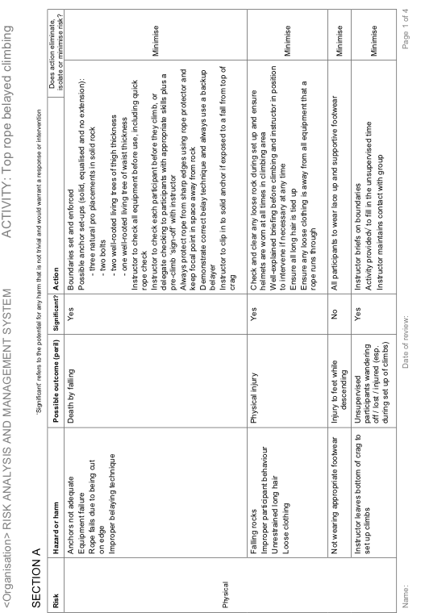
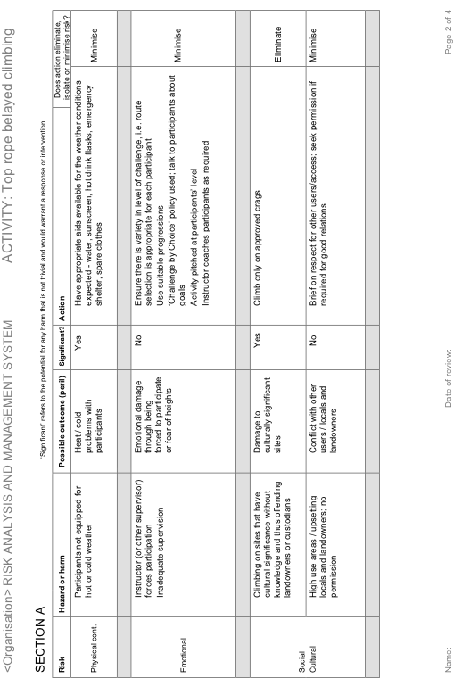
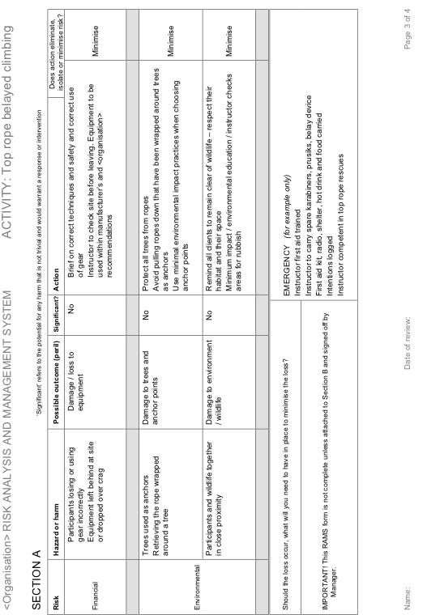
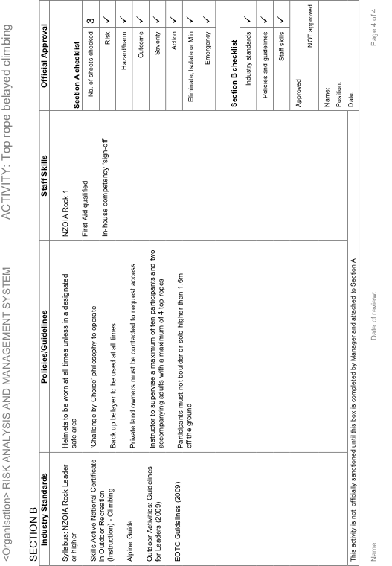
9. Emergencies
New Zealand has its own Search and Rescue (SAR) protocol. All SAR incidents are managed and paid for by the NZ Police. There are locally trained SAR teams throughout the country, comprised mostly of volunteers.
Coastguard units are responsible for safety on their designated stretch of coastline, harbour or lake. They are a good source of local knowledge.
Key Competencies
1. Know:
- what forms of field communication are current, accepted practice in New Zealand
- where to obtain them
- their strengths and weaknesses
2. Know how to call emergency services in New Zealand.
References
www.landsar.org.nz
NZ Land Search and Rescue
www.sarinz.com
Search and Rescue Institute New Zealand
www.maritimenz.govt.nz
Maritime NZ
www.police.govt.nz
NZ Police
www.coastguard.co.nz
Coastguard New Zealand
www.beacons.org.nz
Information on EPIRBs and PLBs
www.wmrs.org.nz
Wellington Mountain Radio Service
www.cnimrs.org.nz
Central North Island Mountain Radio Service
www.mountainradio.org.nz
Canterbury Mountain Radio Service
www.linz.govt.nz
Land Information NZ – information on maps and topographic services
10. Outdoor Organisations
NZOIA is active in maintaining working relationships with other New Zealand outdoor sector organisations.
It is important to understand how NZOIA fits in the overall jigsaw of the NZ outdoor sector and how each organisation inter-relates.
Key Competencies
Understand the role NZOIA plays in the New Zealand outdoor sector.
Understand the role other organisations play in the New Zealand outdoor sector and how that may influence your work and recreation in NZ.
References
www.eonz.org.nz
Education Outdoors NZ
www.fmc.org.nz
Federated Mountain Clubs
www.kask.co.nz
Kiwi Association of Sea Kayakers
www.nzmga.org.nz
NZ Mountain Guides Association
www.mountainsafety.org.nz
New Zealand Mountain Safety Council
www.nzoia.org.nz
New Zealand Outdoor Instructors Association
www.nz-rafting.co.nz
New Zealand Rafting Association
www.caves.org.nz
New Zealand Speleological Society
www.skoanz.org.nz
Sea Kayak Operators Association of NZ
www.skillsactive.org.nz
Skills Active Aotearoa
www.sport.org.nz
Sport New Zealand
www.watersafety.org.nz
Water Safety NZ
www.rivers.org.nz
Whitewater NZ

NZOIA
NZOIA is the professional body for New Zealand outdoor leaders, instructors and guides.
NZOIA was formed in 1987 by a group of professional outdoor instructors wanting to work in a profession with operational and ethical standards governed from within. One of the primary objectives of this new organisation was to establish a nationally recognised qualifications scheme for outdoor instructors.
Rock, kayak, bush and mountain instructor qualifications were developed and assessment courses were conducted. The qualifications scheme received feedback and changed to reflect industry needs. The aim of NZOIA qualifications is to reflect the minimum requirements for a person to lead or instruct others in a given environment and situation.
From 1987, NZOIA slowly grew and gained acceptance. Logbooks started to become commonplace among outdoor instructors and other disciplines were added to the scheme. NZOIA qualifications became the standard for competence in outdoor instruction and are held in high regard by employers. They effectively set the benchmark for the level of expertise necessary within many areas of the outdoors.
At present, NZOIA assesses multi-level qualifications in:
Abseil : Rock : Cave : Kayak : Sea kayak : Canoe : Bush : Alpine : Canyon : Mountain Bike : River Rescue : Wall Climb : Artificial Whitewater
NZOIA provides leadership and support to its members by promoting the highest standards of conduct, safety and instruction, providing quality information and services, and strengthening relationships within the wider outdoor community.
NZOIA believes it is essential that anyone working as a leader, instructor or guide is trained, qualified and up to date. Therefore, NZOIA has a revalidation programme and full details can be obtained from the NZOIA website by downloading the Revalidation Booklet.
NZOIA is actively involved in encouraging the enjoyment and conservation of the New Zealand environment and advocates for standards of professional practice in the environment. NZOIA constantly monitors the outdoor industry to ensure that qualifications remain relevant.
As an organisation, NZOIA continues to grow and refine and is committed to supporting the professional development of its membership.

www.nzoia.org.nz Ph: 03 539 0509 Email: admin@nzoia.org.nz
Assignment Cover Sheet
He Pīkau Mātauranga
Name:
Postal Address:
Email:
Phone (H) (W) (Mobile)
Date submitted to NZOIA:
Delivery Mode: Post Email Other (circle one only)
Plagiarism Declaration
I, (insert name) declare that the attached coursework is all my own work.
Signed:
Instructions
Please write clearly.
Remember to keep a copy of this assignment before posting to NZOIA.
Post to:
Cross Credit
NZOIA
PO Box 1620
Nelson 7040
New Zealand
Assessor’s Use Only
Assessor Name:
Date of Assessment:
Grade: PASS DEFER (circle one)
Notified NZOIA of result: (date)
Posted assignment to NZOIA: (date)
Comments:
NZOIA Office Use Only
Received and filed: (date) Ref. #
By: (name)
- History & Culture
Tasks
- Write 2-3 sentences on each of the following:
- Polynesian settlement
- European explorers
- Treaty of Waitangi
- European settlement
2. Who are:
Ranginui
Papatuanuku
Tāne mahuta
Hine-ahu-one
3. a) What does tangata whenua mean?

b) What does tapu mean?

c) What is an urupā?

d) As an outdoor instructor in New Zealand, how could the above influence your delivery of an outdoor progamme?
2. Flora & Fauna
Tasks
1. a) Give two reasons why there are so many unique native plants and animals in this country.

b) Name three reasons for New Zealand's high rate of species extinction.

c) Explain two ways in which New Zealand is attempting to halt, or minimise, species extinction and environmental harm, e.g. breeding programmes, predator-free 'islands',1080 poison, didymo control, kauri dieback etc.

2. Name six native birds, four of which you would commonly encounter and two which are rare and endangered. If possible, write the Māori and English names.
Name | Habitat | Identifying Features and Characteristics
3. Name six native trees. Include endemic species for both the North and South Islands.
If possible, write the Māori and English names.
Name | Habitat | Identifying Features and Characteristics

3. Weather
Tasks
- Name three sources of weather information you could access prior to an overnight outdoor activity.
- What are the limitations of these three sources of weather information?
- Name two sources of weather information during the activity.
- Describe three practical observations in the field that would indicate to you that the weather is deteriorating.

- Describe the weather in Auckland and Queenstown.
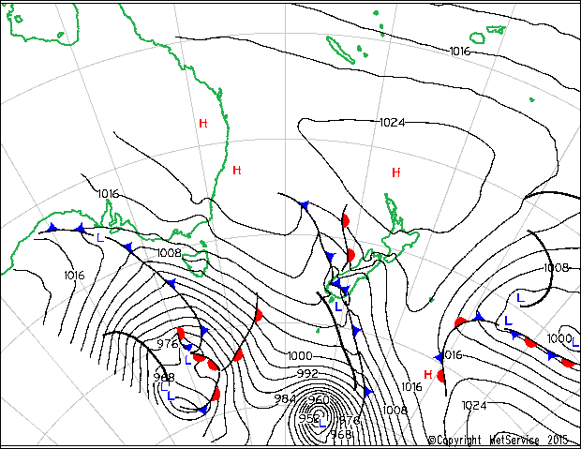
Auckland:

Queenstown:

- What is likely to occur soon in the North Island?
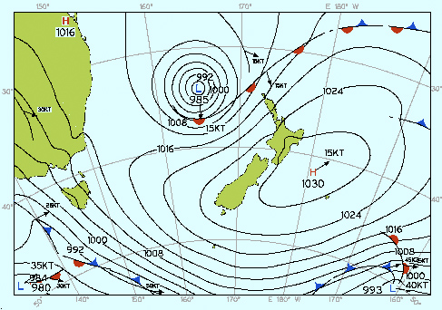
Answer:

7. If the UV index is at 11+, name three risk management strategies you would employ.
1.
2.
3.

4. Geology & Geomorphology
Tasks
1. Draw on the diagram:
a) New Zealand’s position on the boundary of the main tectonic plates
b) Subduction (use arrows to indicate direction)
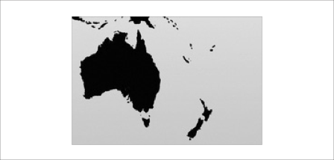
2. a) The position of the main mountain ranges and volcanoes
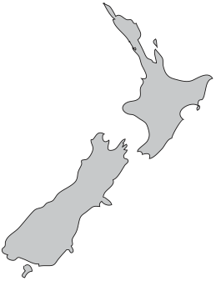
b) The location of the Alpine Fault

3. Name six common rocks found in New Zealand.
 | Name | Areas (max 2) | Appearance and significant characteristic
Volcanic
Volcanic
Sedimentary
Sedimentary
Metamorphic
Metamorphic

4. How does knowing the significant characteristics of NZ rock help you when choosing routes out in the field?

5. Environmental Care
Task
- How would you implement the Leave No Trace Principles when camping with a group?
- Name two ways in which you would instill values of care and sustainability.
6. Land Access
Task
- Locate the outdoor recreation area of Tongariro National Park in the central North Island and describe:
a) The current land tenure designation.
b) The specific issues, considerations and restrictions relating to outdoor recreation.
7. Health & Safety
Tasks
- Summarise the main objectives of the HSW Act regarding the responsibilities of employers and employees.
- Describe the role of the Worksafe and Maritime NZ in the workplace.
- What would you do if there was a serious harm incident at your workplace? Make specific reference to legal requirements.
8. Safety Management
Tasks
- With reference to NZOIA syllabi and OutdoorsMark describe the current, accepted practice for determining ratios of leaders / instructors to participants.
- Write a safety plan for an outdoor activity in New Zealand. Your group comprises a maximum of ten people.
(Use additional paper for your answer as needed.)
9. Emergencies
Tasks
- Communication devices
 | Comm. device | Where to obtain | Strengths | Weaknesses
1.
2.
3.
4.
5.

2. What is the number for emergency services in NZ and what information should you have to hand when you call?

10. Outdoor Organisations
Tasks
- Explain the role of NZOIA.
- Choose five other organisations listed in the References section and write a short paragraph explaining their role.

